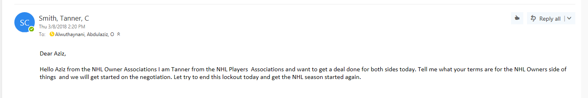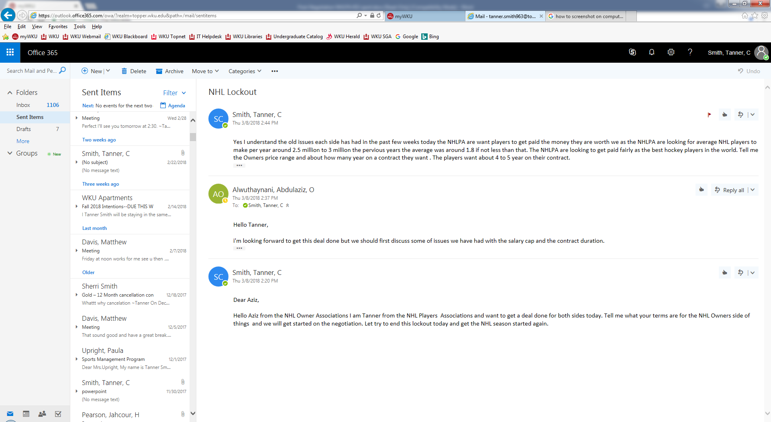
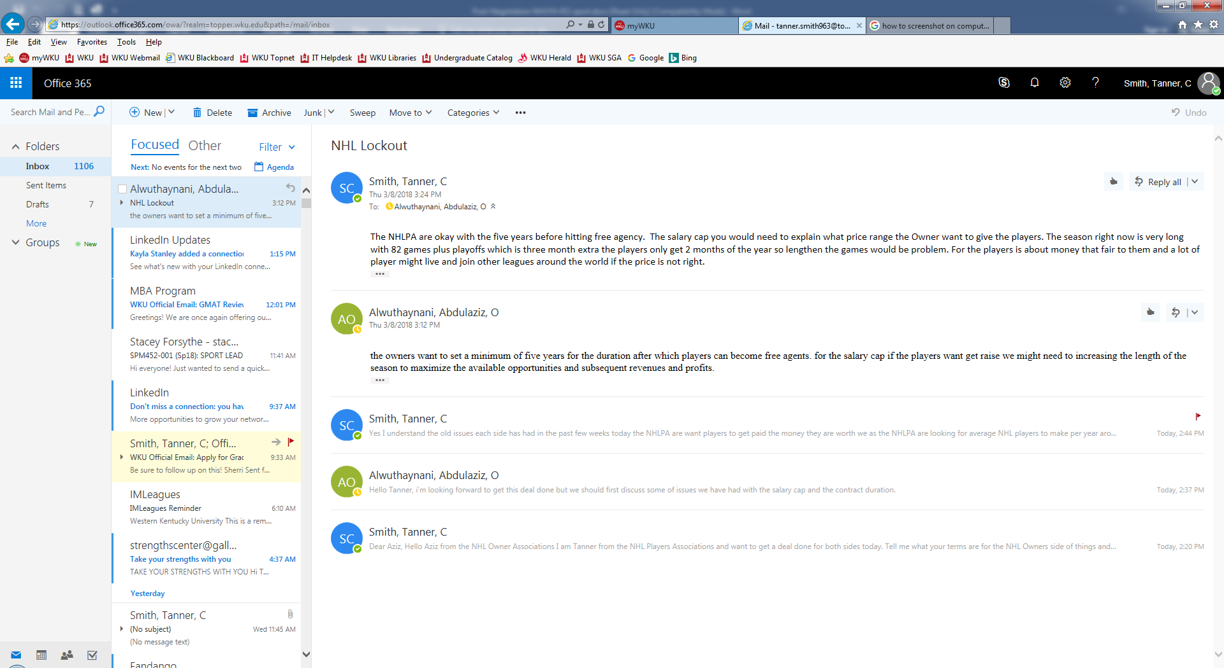

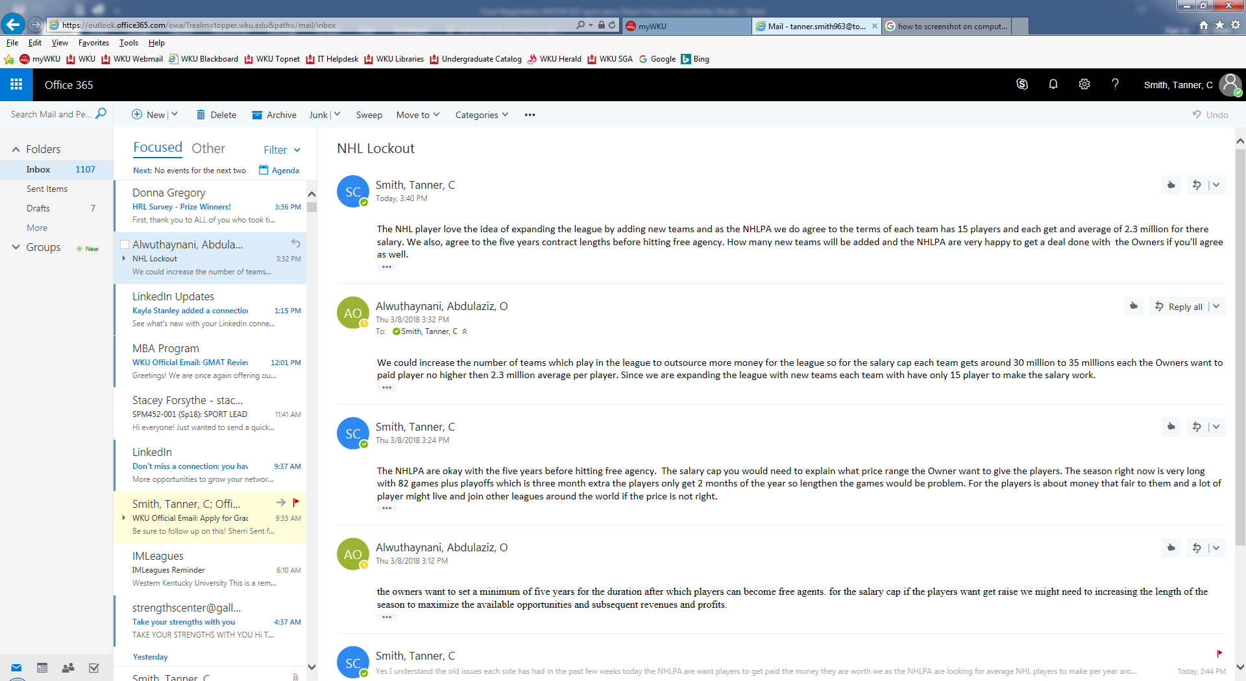

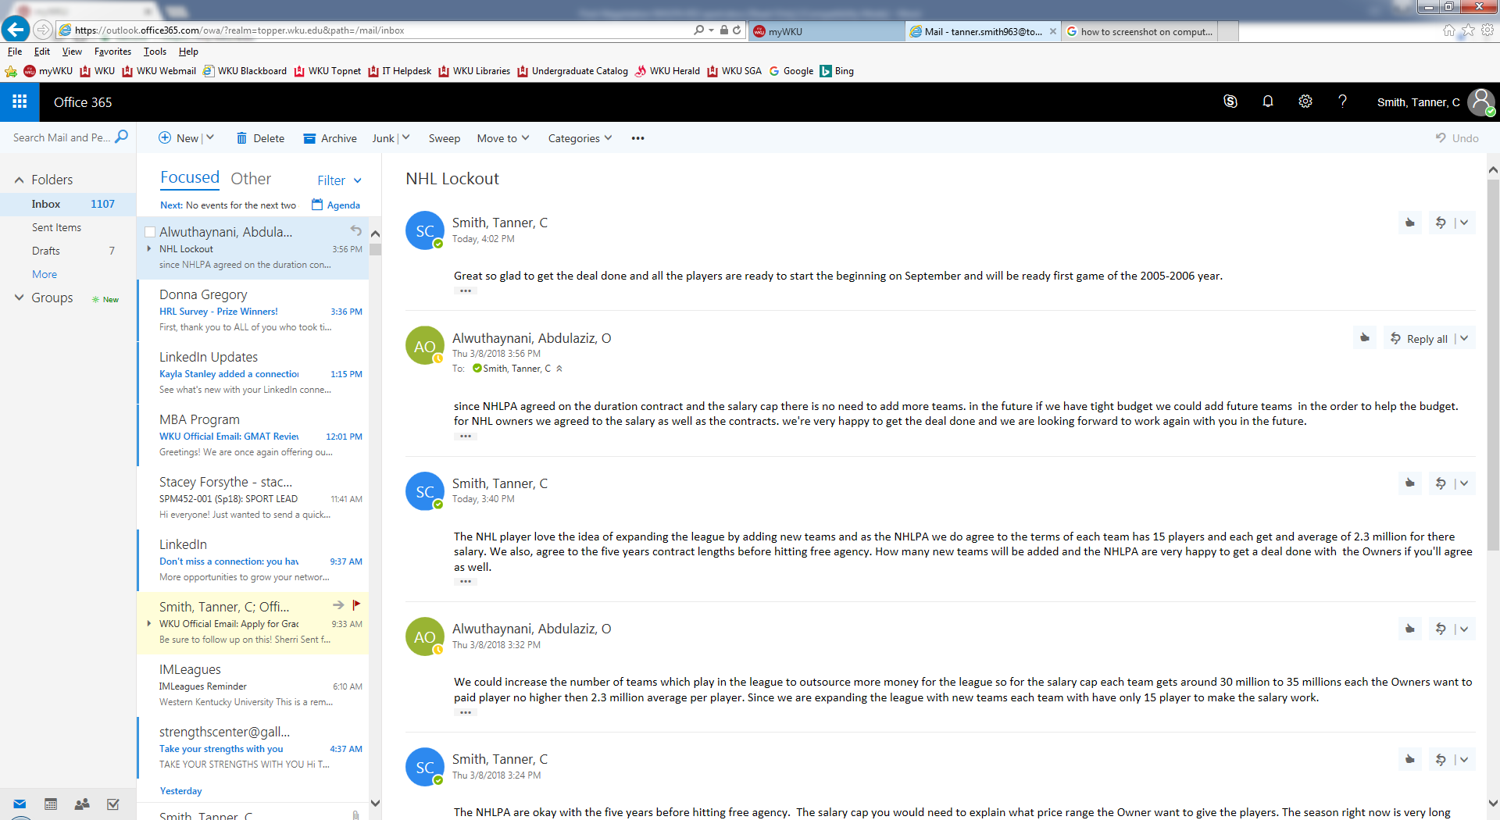
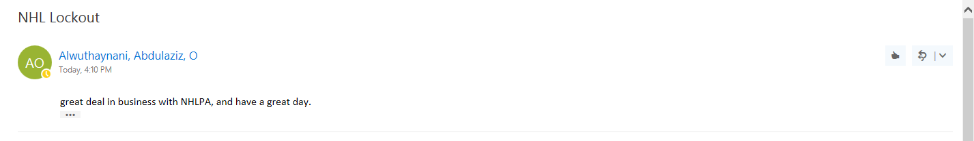

Both NHLPA and the NHL Owners association are very happy today by getting the deal done. Both side got rid of the issues from the previous weeks and glad to be on the same paper this week. The NFLPA agree to the salary caps which was around 30 million to 35 million per player get around 2.3 million average which was a bit lower for the player 2.5 million average but was ready for the new season to start. The NHL lockout is over for the 2005-2006 year and the players and owners got it done. The player are ready the beginning of September to start the new NHL season.

